PLAYING TO YOUR STRENGTHS
The purpose of this module is for you to build an awareness of your own strengths (2/3rd of the population are unaware as to what their true strengths are), how to use them effectively and their potential pitfalls.
The Strengths philosophy has been around for some time, Peter Drucker, a management guru of the 1960’s talked of it, and focuses on those things that energise us, as opposed to being the things that we can and can’t do.
Notes

What are the benefits of focusing on our strengths? Well the research shows that if we do this, we feel more engaged in our work, we are more resilient and more confident. Often we have been talk to fix weakness, but the reality is that none of us can be good ‘all-rounders’, and by trying to fix weakness we will find ourselves drained and un-motivated. That is not to say we ignore them, but we approach them in a different way….more of that later!

Strengthscope
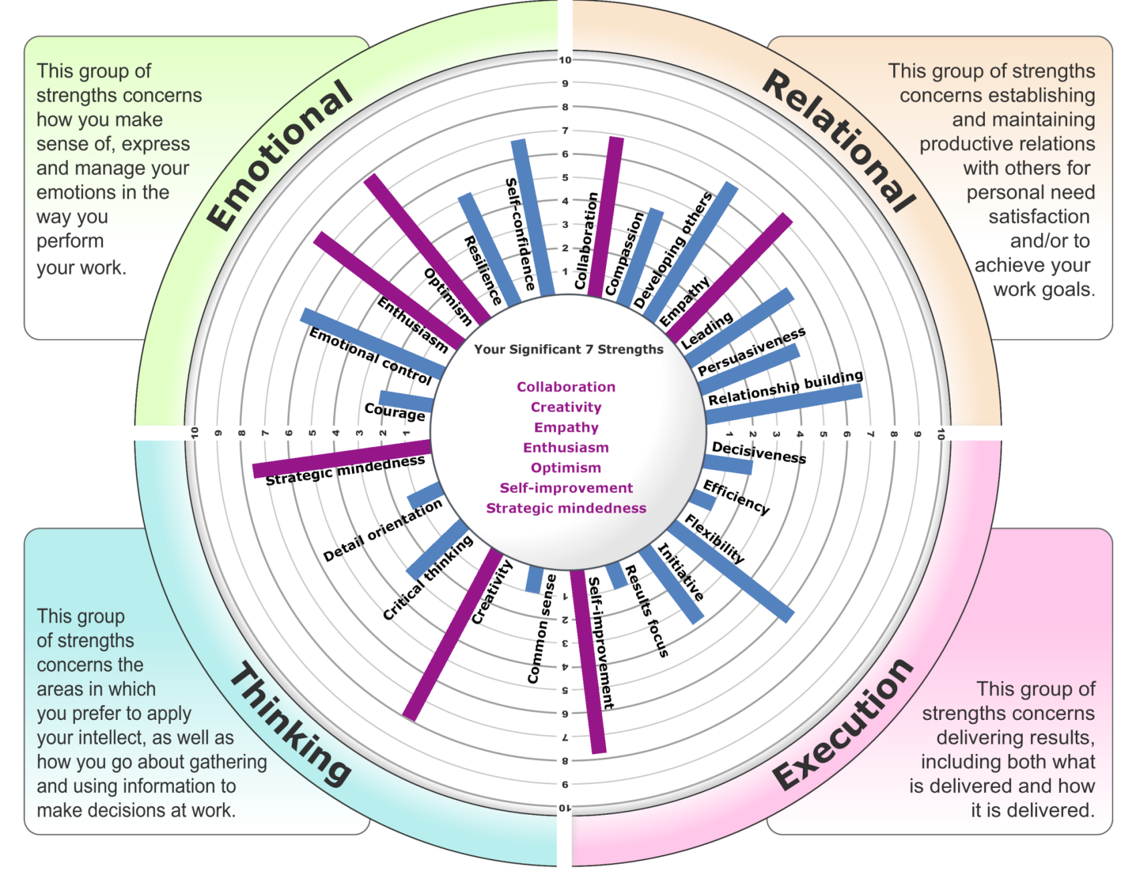
Strengthscope was a psychometric tool developed by Dr Paul Brewerton and James Brook of Strengths Partnership in 2006 and identifies an individual’s 7 significant strengths.
There are 24 strengths in total and they are divided into 4 different groups:
EMOTIONAL – This group of strengths are about how you make sense of, express and manage your emotions at work
RELATIONAL – This group are about how you establish and maintain relationships to achieve your goals
THINKING – These are about the areas in which you prefer to apply your intellect, as well as how you go about gathering information and use information to make decisions
EXECUTION – These are about delivering results, including what and how

Stretching Your Strengths
DISCOVER
Opportunities in or outside your current role

DEVELOP
Skills and knowledge
DRILL
Productive routines through practice,
review and improvement

Performance Risks
Strengths in Overdrive
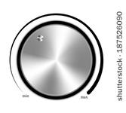

Often we find that it is in fact our strengths that can be our downfall. These are things that we enjoy doing and unless we are very self aware, they can easily go too far and be detrimental. E.g if we have a decisiveness strength, we find it easy to make quick decisions, even when we don’t have all of the information to hand. If this goes into overdrive, we are potentially making a decision too quickly and then wish we had taken more time, or have to change our decision.
The way we deal with this is to look at the other strengths we have and lean on them more to thus turn down our strength in overdrive e.g. if we had decisiveness in overdrive, and we had a strategic mindedness also as a strength, we could consciously use this more when having to make decisions. By looking at the bigger picture in effect, we could be less hasty in making a decision.
Notes

How to use Strengths as Moderators
We can use our significant strengths to help ‘turn down’ our strength in overdrive. For example:

STRENGTH IN OVERDRIVE + STRENGTH TO TURN THIS DOWN = OPTIMISED

Self Confidence Empathy
Could be perceived as being arrogant By reminding yourself to step into the other person’s shoes

Empathy + Common Sense
Loses objectivity, seeing things too much from By remembering to step back and using
the other person’s point of view logic

Non-Strength
There are two types of non-strengths (blue bars):
Allowable Weakness – these are our non-strengths that are not required for the role that we are in, therefore are not having a detrimental impact e.g. Strategic Mindedness – if the individual is not in a role that is strategic then Strategic Mindedness may not be required, hence a lack of energy for it, does not cause a problem.
Limiting Weakness – these are our non-strengths that are having a detrimental impact as they don’t energise us, we have not yet learnt how to manage the impact of them, and they are required for our role e.g. detail orientation. If this is a limiting weakness, the person is not energized by detail and they are making mistakes frequently.

Limiting Weaknesses
Take a look at your non-strengths and see if any are having a negative impact.
We have 3 different strategies to deal with a limiting weakness:
- Focus on using one of our other significant strengths more
- Bring someone else in to the situation who has this as one of their significant strength
- Focus on building productive habits

LIMITING WEAKNESS + SIGNIFICANT STRENGTH = OPTIMISED
Lean on one of our significant strengths
Detail Orientation + Efficiency
Making mistakes By creating systems and processes to highlight mistakes
Bring someone else in with a useful moderating strength
Detail Orientation + Someone in the team with an efficiency strength
Making mistakes Team member proofs reads documents before released

TALENT DYNAMICS
We are brought up in a world where we are encouraged to try and be a ‘good all rounder’, but there is no such thing! By heightening are awareness of the activities that take us into ‘flow’ and out if it, we begin to drive engagement, trust and performance.

- The Concept of Flow

‘Flow’ is a concept created by Hungarian psychologist Mihaly Csikszentmihayli. When we are in ‘flow’ we are loving what we are doing, the time flies and we find that we are at our best. There is always a certain amount of challenge, but it is an enjoyable challenge.
- Talent Dynamics

Talent Dynamics is a psychometric profiling tool developed by Roger Hamilton, Founder of the Entrepreneurs Institute, and is used by over 600,000 entrepreneurs around the world.
Any psychometric is basically saying we are a mix of 4 energies, by learning to operate mostly in our area of ‘flow’ and
surround ourselves with others that are in ‘flow’ doing the things that take us out of flow, this is when the team becomes balanced and performs at it best. It also highlights how to get the most from our teams, as it tells us the work activities they are most likely to enjoy. For this reason it can be a very useful tool to use when recruiting, to help inform the process.
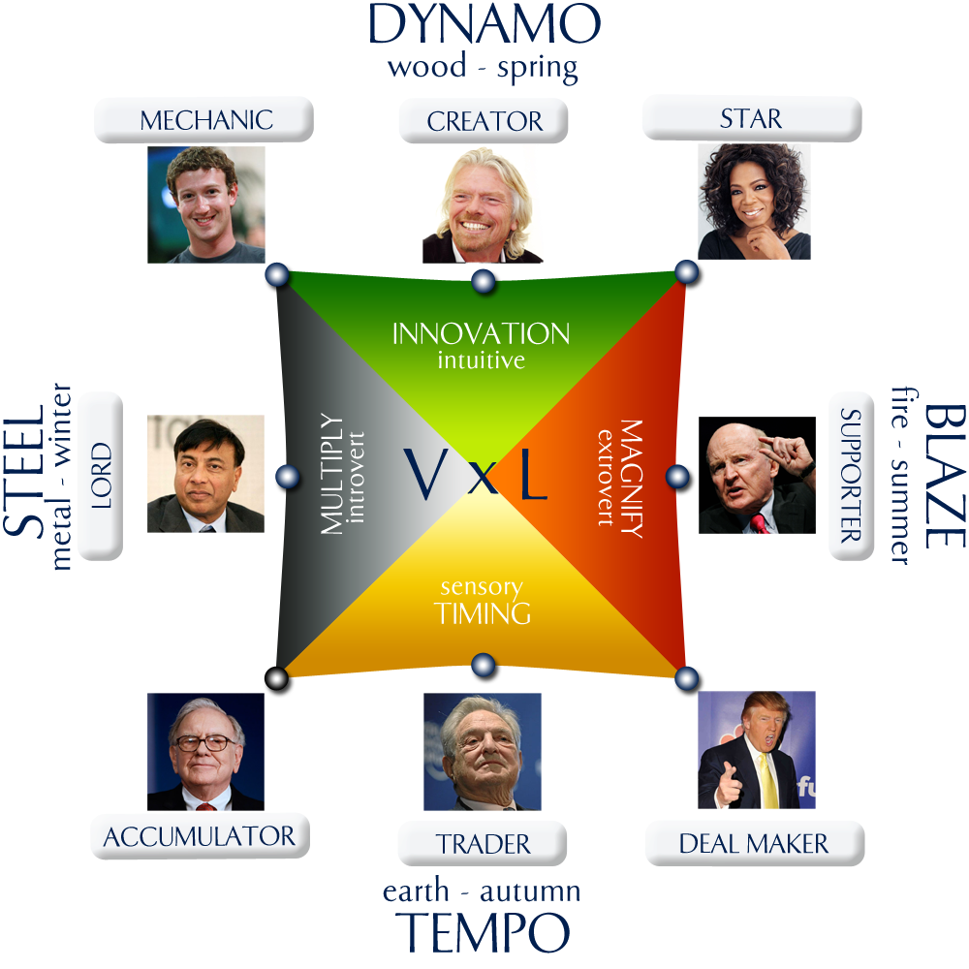
In summary we have four key energies:
DYNAMO – These people are very creative, and are good at coming up with new ideas. They are very intuitive and are great at looking at the long-term vision, coming up with a strategy of how the company could grow.
These people tend to ask questions beginning with ‘WHAT?’
BLAZE - Often the primary energy for trades people. These individuals love being out and about seeing clients and the team, and are often naturally good at sales, enjoying activities such as networking.
These people tend to ask questions beginning with ‘WHO?’
TEMPO – These people are very service oriented and are the opposite of the dynamo energy. They naturally can sense if clients or the team are unhappy and what to do to adjust. They also have a natural sense of timing.
These people tend to ask questions beginning with ‘WHEN?’
STEEL – This is all about the detail, so these people enjoy analysing the numbers and looking at trends. They are often good at thinking in a logical manner and can plan out projects really well.
These people tend to ask questions beginning with ‘HOW?’

Understanding which is your primary strength is key, as it identifies who potentially is missing in the team. Basically you should have a mix of the different energies in the business, for it to be balanced.

In simple terms, if everyone is great at being out there seeing the customers and winning the work, but there is no-one back of house ensuring that there is a process in place to deal with the work, it will fall down. Similarly if everyone is great at the detail and the systems, but there is no one in place to go out and win the business, you will have a very efficient business with no customers!

The 8 Roles in Business
Within the Talent Dynamics system there are 8 defined roles that are required in any business. This doesn’t mean that you need all 8. They are:
CREATOR – These people love creating new things, find it easy to think about the long term vision of their company, but can be easily distracted by what I call ‘shiny new object syndrome’!
Ideal roles: Product creation, business strategy
STAR – These people have mainly a mix of the dynamo blaze energies, and therefore are very good at anything to do with sales and marketing. Generating leads and public speaking come very naturally to them, but they generally don’t enjoy detail or sitting in back of house roles!
Ideal roles: Sales and marketing, public speaking, networking
SUPPORTER – For these people, it is all about the team and the team’s success. They therefore make natural leaders, and are great and motivating and inspiring people. They love to talk and like stars don’t enjoy back of house tasks or looking at detailed spreadsheets!
Ideal roles: Leading a team, sales, networking

DEAL MAKER – These people have mainly a mix of the tempo and blaze energies and while they are extrovert, they tend to be much more comfortable one on one as opposed to speaking to a group. They are great at negotiating and closing deals, but again are generally not good with organization and detail.
Ideal roles: Closing sales, negotiating, networking
TRADER – For traders it is all about harmony for the team and for the customers. They are great at making sure everything is fair and sensing when things are not going well. They therefore make great customer service people or human resource managers. They may find thinking about the long-term vision and coming up with ideas a challenge.
Ideal roles: Account manager, HR, customer services
ACCUMULATOR – These people do enjoy detail and because they are a mix of the tempo and steel energies they are also good with timing, therefore make great project managers. They can be relied on to manage the details well and to make sure that all the elements of a project are planned out in the right order. However don’t ask them to go out networking or public speaking, they probably will hate it!
Ideal roles: Project manager, PA, office manager
LORD – Lords tend to love numbers and the detail so they are great at finance manager roles, analyzing trends and the detail behind the business. Again they are unlikely to enjoy networking and sales, preferring to be in the background analyzing where there are opportunities to drive efficiencies.
Ideal roles: Finance manager, business analyst
MECHANIC – These people love to come in and improve the way things are done, implementing systems and processes to drive efficiencies and make things run more smoothly. They generally don’t enjoy so much managing people or sales and marketing.
Ideal roles: Implementing systems and processes, Operations

Once we know where the business owner is on the square, we follow the 1,2,3 process i.e. 2 steps around the grid from their position, and then 3 steps which highlight the ideal 2 other profiles that they should either have in the business, outsource to or partner with.

